**Check in:** The last day of Ramadan is May 13th. Ask the Kids what they do on this evening? Why is it special? What is the last day of Ramadan called?

**Homework help**: Ask the students to share their screen and show you what they are working on. If you are having trouble getting the students to share below are some questions you can ask to stimulate the conversation on what they are learning and what they may need help on.

Ask questions like:

* What homework did you have this week?
* Can you show me you English/math/ history…?
* Can you tell me about what you did in history/English/ math/ science this week?
  + Can you explain it to me?

***NOTE****: I always make 2-3 extra rooms. If you need to do some one on one homework help send me a text and I can move you or hit call host. You can also go back to the main room with the student though there may be other people in the main room.*

**Brain break game**: Guess Who?

* Have the students ask yes/no questions to guess which monster you are thinking

**Games**: use this link to play ‘bomb party’ a spelling game <https://jklm.fun/>

* You have the kids all login using the link provided in the top right corner of the game.
* They then have to spell a word using the letter that appear on the bomb
* Copy the link on the top left corner and paste it in the zoom chat. Students can then log in and play for themselves

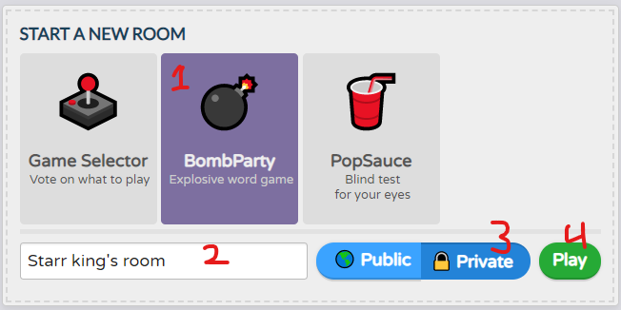



**Wrap up** finish working on what you are working on or transition to the game.